University of the West of England

BIOCOMPUTATION

Data Mining using a Genetic Algorithm

By
Thomas Hughes
Student Number: 15022110
Link for code at end of report
How using Evolutionary GA’s can help with data mining.

Thomas Hughes. Student Number 15022110

1 INTRODUCTION

The Task given was to use a form of evolutionary intelligence to solve Data mining classification problems. There are many kinds of evolutionary intelligence techniques, for this task a Genetic Algorithm (GA) is used. A GA uses heuristic search to copy the processes of natural evolution. The GA uses different stages such as Initialising the population, fitness function, Selection, Crossover, and Mutation. By representing genes that make up an individual’s chromosomes, with a binary string (0,1) By using these genes, it is possible to use a set of rules which can be used to find patterns in large data sets.

This paper is to demonstrate how GA’s can evolve a classifier and to explain what happens when the GA’s parameters are changed. To show what happens during the experiment, the result will be displayed in graphs to give a visual of what is going on.

2 BACKGROUND RESEARCH
The process of Data Mining is the drawing out of useful and unknown information from data. The primary objective is to create an intelligent computer program that can automatically traverse through a vast amount of data that is found on the database. The program searches the databases to find hidden patterns in the data; these patterns are generalised to make predictions on data that is used for future purposes. A lot of patterns will be mundane and not very useful. The main problem with real data is in its imperfections, e.g., parts of the data might be missing or mixed. So the Algorithm has to cater to all of this imperfection (Ian H. Witten & Eibe Frank 2005).

Data Mining is used in lots of different industries in many ways, for example, predicting the patterns in the stock exchange, Research Analysis and Financial Fraud Detection (FFD). FFD uses Data Mining to prevent the devastating repercussions of Financial Fraud (E.W.T. Ngai, Yong Hu, Y.H. Wong, Yijun Chen & Xin Sun 2010). For instance, Billions of Dollars are lost every year Due to fraud (Philip K. Chan, Wei Fan, Andreas, Prodromidis, and Salvatore J Stalfo 1999).

GA’s are popular with data mining because it is possible to find an optimal solution. This is done through fitness evaluation, selection, crossover, and mutation. The fitness evaluation is critical in this algorithm because everyone in a population is compared to see which the fittest candidates are to mate and produce offspring.
GA’s can search a solution space without constraints and considers all possible and practical solution regions. As a result, it is possible to explore regions that haven’t previously been explored and increases the possibility of an overall optimal solution (Shital Shah, Andrew Kusiak 2005).

There are many techniques other than GA that is used in data mining such as Artificial Neural Networks, Decision Trees and Particle swarm optimisation
- Artificial Neural Networks (ANN) ANN’s are trained at first to acquire an accuracy rate. Then unnecessary connections used in the network are removed utilising a pruning algorithm. Values in hidden units are analysed, then classification rules are generated (Hongjun Lu, Rudy Setiono, & Huan Liu 1996)
- Decision Trees take an object or a set of properties as inputs and outputs, yes or no, which is a Boolean function. These Boolean functions are then combined with a hierarchical structure which forms the tree shape. Decision trees are fast and efficient ways of classifying datasets entries (M.J. Aitkenhead 2008).
- Particle swarm optimisation (PSO), was first introduced by Russel Eberhart and James Kennedy in their paper A New Optimizer Using Particle Swarm Theory they got their inspiration from the behaviour of birds flocking and fish schooling. By taking a candidate solution and iteratively improving it, the objective function optimises. Every particle in the PSO represents a candidate solution to the problem. The particles are affiliated with velocity and position by using their own experience and its neighbouring particles experience(K.N.V.D. Sarath, Vadlamani Ravi 2013).

3 EXPERIMENTATION

3.1 Data Set 1
The basic Genetic algorithm has been coded in Java and designed using classes; the algorithm has all the fundamental processes that you would find in a GA. The simpGenAlgMain Class holds the main method for the algorithm along with global a variable call GENS that represents the amount of generation that the algorithm will iterate through. When the program is started, it calls the initiateDataPop(), that initiates the population of individuals. It moves on to initiate the data set and rules when this is done the data1 file consisting of 32 sets of conditions and outputs are read in using the readDataFromInputFile() located inside the GeneticAlgorithm class, within this function it reads in the data into two ArrayLists, number1 and numbers2. The first five bits (condition length) go into number1 and the action points(output) the sixth bit goes into number2 this is where the data1 file is copied into the rules class to set the conditions setCondition() and set the (output) action setAction(). After the rules are set up with the actions and conditions, In the simGinAl class, there is a for loop that iterates through the generations that have been specified with a global variable GENS. When executed, within the for loop tournementSelection() is called, the individual candidates are chosen by comparing the candidate's fitness, the best individuals get selected as the best parents. The parents go on to create offspring in the crossover() where the ends are switched to generate the offspring; the next process is mutation() where it is possible to control the amount of mutation using the Mutation rate. The population is evaluated where the fitness is calculated based on the new rules. Then the previous generation is overwritten to avoid getting stuck in a local maxima using OverwriteCurrentPopulationToAvoidLocalMaxima(). After being overwritten the evaluatePopulation () is called to evaluate the new population. At the end of each generation the best Gene, fittest individual, and the average fitness are printed out. Through each iteration, the rules learn and evolve improving the fitness until it reaches a global maxima.

The Fitness and the Rules

The rules calculate the fitness which forms the base of the system. When the 32 sets of conditions and outputs are pulled into the rules from the data files, then over time the rule set evolves which classifies the given of input. For instance, the solution set 00###0 0 could match 000000 0 or 001110 0 which means it could correctly capture more than one data set. The fitness relies on how much of the inputs the system can classify correctly.

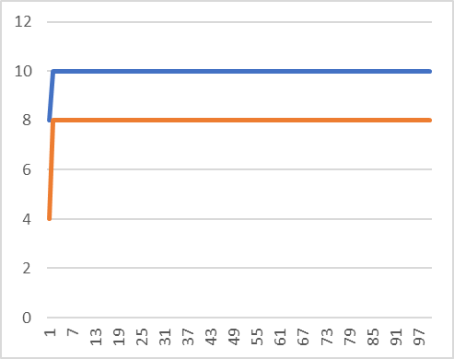Blue = Fittest
Orange = Average Fitness
Figure 1, The results from the first graph are the results of the 32 sets of conditions and outputs that are tested against the individuals of the population. Even though it is possible to improve a group of individuals average fitness to around 24 and best at 32, it cannot be done without wildcards as you can see from the graph peaks at 10, and the average peeks at 8 this is done with generations = 100, population = 100, mutation = 0.09 and the number of rules = 10. I have chosen these inputs because it is the highest it can reach without wild cards.

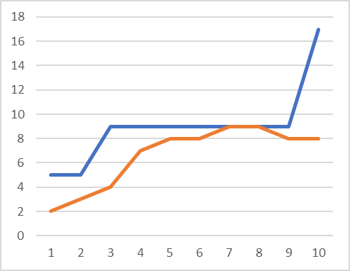
Blue = Fittest
Orange = Average Fitness
Figure 2, The second graph shows the results, with the inputs of generations = 10, population = 10, mutation rate = 0.04 and the number of rules = 1, by dropping the mutation rate and the number of rules, you can easily see the drastic changes, the results show that the fittest individual peeks at 17, and the average settles on 8. This shows that having wildcards and by changing the input variables makes a huge difference compared to figure 1.
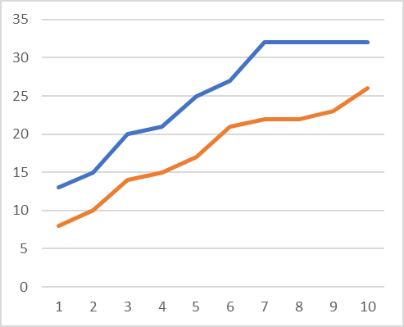
Blue = Fittest
Orange = Average Fitness
Figure 3, Shows that with wildcards it is possible to reach above the predicted amount of fittest being 32 and the average of 24, with the result of fittest being 32 and average being 26. This was done by using these variables generation = 10, population =10, mutation = 0.09 and rules = 7. These are stable inputs meaning by keeping the population lower stops the program from running slow, when the problems the application must solve starts to grow in scale, the time it takes to solve grows as well, which isn’t very efficient. The mutation rate when high allows for more diversity in the genetic information of the population and can also help prevent reaching a local maxima if the mutation is to low it can take a lot of time to traverse the search space. The number of rules affects the fitness of the individual population greatly, with a low number of rules it lowers the amount of classified pattern matching which keeps the fitness very low compared to having a lot of rules which increases the matching of the data set creating many fitter individuals.

3.2 Data Set 2
To get data set 2 working properly only a few lines of code were added to the original algorithm to get it running smoothly, so there isn’t much of a difference in how the algorithm works.
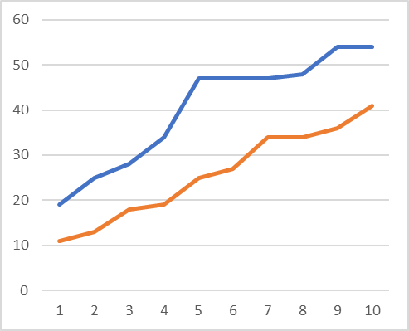
Blue = Fittest
Orange = Average Fitness
Figure 4, Shows the results for Data Set 2 which consists of 64 sets of conditions and outputs, the max fitness it is possible to reach is 64. With the same input variables as Figure 3, generation = 10, population =10, mutation = 0.09 and rules = 7. Even though they have the same input variable there is a big difference in fitness, the fittest being 54 and average being 41. Showing that having more conditions in the data set improves the performance of generalisation which increases the fitness drastically. Even though the max fitness hasn’t been reached it is still a good result compared to figure 3.

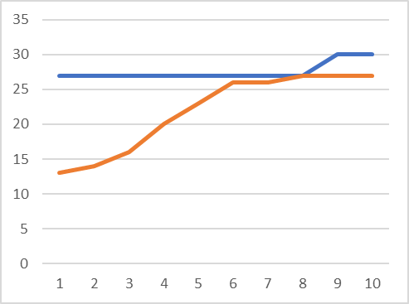
Blue = Fittest
Orange = Average Fitness
Figure 5, Shows by reducing the mutation rate quite a bit shows a massive change in both the fittest and the average fitness, the variables used are generation = 10, population = 10, mutation = 0.001 and rules = 7. The fittest started high at 27 and stays there for eight generations until nine where it stays at 30, and the average started at 13 and finished at 27. Compared to figure 4 it is easy to see that changing the mutation rate, has a huge effect on the search space. This also shows that the fitness can get stuck around a local maxima without more diversity in the genes.

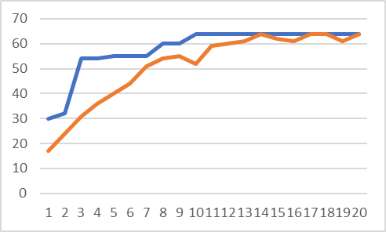
Blue = Fittest
Orange = Average Fitness
Figure 6, was to show that Through a lot of experimentation of changing the variables, it is possible to reach the fittest individual of 64 and an average of 64. The fittest was reached in the tenth generation, and the average was reached in the seventeenth generation, this was done by using the input variables of generation = 20, population = 10, mutation = 0.02 and rules = 10.

- Generations = 20 was used because the algorithm needed time to evolve the data set.
- Population = 10 was used because it worked out if it were set any lower it would be tough to achieve the fittest and average of 64 with that number of individuals.
- Mutation Rate = 0.02 was used because through experimentation I have found that this is very efficient with finding the fittest individual, even though technically there is no real optimal mutation rate it can be found through experimentation.
- Number of rules = 10 was used because it increases the amount of classification.
Here are the printouts of the result that were used to
create the graph.

Figure 6 results Generation: 20
Best Gene: 01011101111212010020222011012211220111002100002022222210221021102222222122222220
WildCards:-
0101110 1
111#1#0 1
00#0### 0
1101##1 1
##01110 0
#10000# 0
######1 0
##10#11 0
####### 1
####### 0
Fittest Individual: 64
Total: 640
Average: 64
Fittest Average,
30 17
32 24
54 31
54 36
55 40
55 44
55 51
60 54
60 55
64 52
64 59
64 60
64 61
64 64
64 62
64 61
64 64
64 64
64 61
64 64

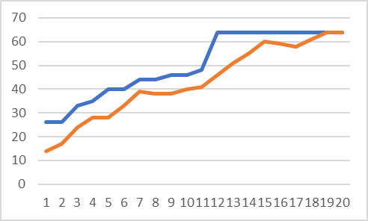Blue = Fittest
Orange = Average Fitness
Figure 7, Shows the results of the fittest individual of 64, that can be achieved with the lowest possible input variables which are generation = 20, population = 10, mutation = 0.02 and rules = 5. This was done through experimentation of adjusting the variables, like in prior graphs to find the desired results. Both the fittest and average Individuals reached 64, compared to Figure 6 the charts are very close with the fittest of Figure 6 reaching 64 in generation 10 and the average reaching 64 in generation 17 while Figure 7 reached the fittest in generation 12 and the average in 19 — this show that there are only two generations differences between them. The main differences between the results are how they reach these results, in Figure 6 the fittest individual hit 54 in the third generation, while Figure 7 didn’t reach 48 until eleventh generations showing that with more rules initiated the fitness will rise much faster.

Here are the printouts of the result that were used to
create the graph.

Figure 7 Results
Best Gene: 10121201222122111022110022222220222222210222001111201110202121211201002000100110

WildCards:-
101#1#0 1
###1##1 1
10##110 0
####### 0
####### 1
Fittest Individual: 64
Total: 640
Average: 64
26 | 14
26 | 17
33 | 24
35 | 28
40 | 28
40 | 33
44 | 39
44 | 38
46 | 38
46 | 40
48 | 41
64 | 46
64 | 51
64 | 55
64 | 60
64 | 59
64 | 58
64 | 61
64 | 64
64 | 64
Implementation of Wildcards
Figures 6 and 7 printed out results show that with the wild cards implemented, it is possible for the rules to capture every data sets.

No mutation rate implemented
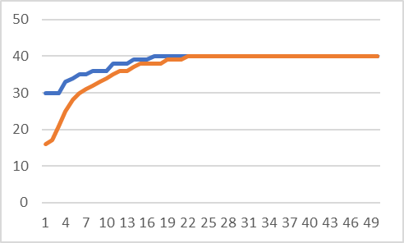
Blue = Fittest
Orange = Average Fitness
Figure 8, Show the results of the GA without Mutation implemented with the variable inputs of generation = 50, population = 30, mutation = 0.0 and rules = 10. Even though the population and the generations are quite high, the results show that it doesn’t help with the fitness value of the population because in the 18 generation the fitness gets stuck at 40 and stays there till termination. This shows there is no diversity in the population; it stops evolving towards the optimal fitness.

4 CONCLUSIONS
In conclusion, the algorithm achieved the peak fitness in both dataset 1 and dataset 2 by reaching the fittest individual of 32 for dataset 1 and 64 for dataset 2.; these results were acquired from the algorithm being able to classify each data set into rules. The number of rules is important because they affect how much generalisation is used in the data which affects the fitness. The amount of generations is important because the algorithm has a longer amount of time to evolve the data if there are too many generations it can cause the algorithm to slow down and if there isn’t enough, the candidates won't evolve to the desired fitness. The population size is important because if it’s too big, it can cause the GA to run slowly, while if the population size is to small the mating between the individuals won’t be diverse, enough to find an optimum candidate. The mutation rate was significant in the experimentations a high mutation rate brings in diversity into the population, but if it is too high the amount of diversity can result in good candidates being lost thought the generations. If the mutation rate is to low there isn’t enough diversity which causes it to reach a local maxima. The mutation rate is typically 1/population, but I wanted to experiment to see the results.
I have learnt:-

- How Genetic algorithms work and how the different processes work for example, how selection, crossover, mutation and evaluation can take a population of individuals and find the optimum solution.
- How GA’s are a good solution for data mining.
- How generalisation turns patterns into predictions for future datasets.
- How there must be a balance with all of the input variable because it can make drastic changes to the results.
- That there are many other techniques for data mining such as decision trees, Artificial Neural Networks(ANN), Particle Swarm Optimization(PSO).
- That it is possible to create a Genetic Algorithm with a lot of other languages such as c, c++, c#, python, in many ways they might have been a better choice.

Next time: -

- I’d like to design another technique like a decision tree and compare the results from both experiments.
- I’d like to implement Dataset 3 and design an Artificial Neural Networks(ANN), to use the ANN weights to solve the problem space.
- I’d like to learn another language like python and implement use the API with GA’s.
- I’d like to use one-hole program to solve the problem instead of using three applications 1. For dataset with no wildcards and 2. For dataset1 with wild cards and 3. For dataset 2.

REFERENCES
Witten, I.H., Eibe, F. and NetLibrary, I. (2005) Data Mining: Practical Machine Learning Tools and Techniques [online]. 2nd ed, pp 4.

Ngai, E., Hu, Y., Wong, Y., Chen, Y. and Sun, X. (2011) The application of data mining techniques in financial fraud detection: A classification framework and an academic review of literature. Decision Support Systems. 50 (3), pp.569

Chan, P.K., Fan, W., Prodromidis, A.L. and Stolfo, S.J. (1999) Distributed data mining in credit card fraud detection. IEEE Intelligent Systems and their Applications. 14 (6), pp.67-74.

Shah, S. and Kusiak, A. (2006; 2007) Cancer gene search with data-mining and genetic algorithms. Computers in Biology and Medicine. 37 (2), pp.251-261.

Lu, H., Setiono, R. and Liu, H. (1996) Effective data mining using neural networks. IEEE Transactions on Knowledge and Data Engineering. 8 (6), pp.957-961.

Sarath, K.N.V.D. and Ravi, V. (2013) Association rule mining using binary particle swarm optimization. Engineering Applications of Artificial Intelligence. 26 (8), pp.1832-1840.

Link to GitHub
trw2-hughes, GeneticAlgorithm, (2018) GitHub repository: https://github.com/trw2-hughes/GeneticAlgorithm

